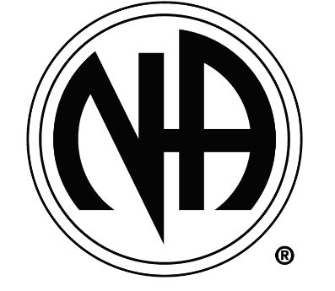


Narcotics Anonymous (NA) Meetings & Information – 12 Step Program
Support line: 650-802-5950
Spanish Website & Contact line: 855-667-2262
Peninsula NA Meeting Website
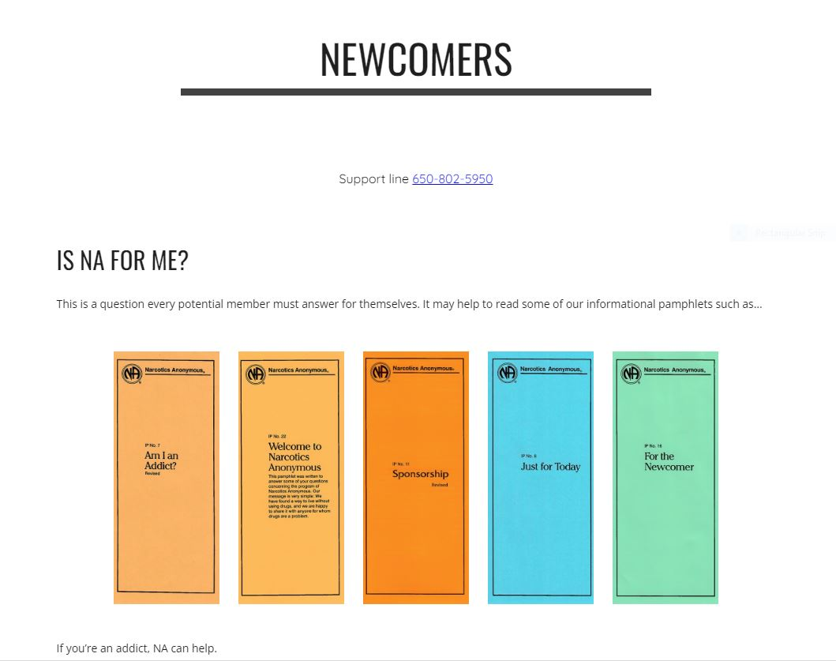
Meeting Schedule

FAQ
What is NA?
Narcotics Anonymous is a fellowship of people who share their experience, strength and hope with each other so that they may solve their common problem and help others to recover from drugs (including alcohol)
Are there Requirements to Join?
The only requirement for membership is a desire to stop using drugs
Is this free or do I have to pay to join?
There are no dues or fees for NA membership. The primary purpose of AA is to stay sober and help other addicts achieve sobriety
What is a 12-Step AA Program?
The 12-Step program, first developed and used by Alcoholics Anonymous, is a 12-step plan in order to overcome addiction and compulsions. The basic premise of the model is that people can help one another achieve and maintain abstinence from substances of abuse, but that healing cannot come about unless people with addictions surrender to a higher power.

State/World Resources

This higher power doesn’t need to be a traditional Christian version of god – it can be as simple as the community of the 12-step meetings, the universe, or a different version of a high power fit for one’s type of spirituality

